I was having some problems setting this up, as the connection kept dropping and things were unable to be found.

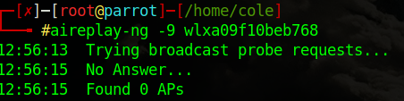

but I discovered that using the airmon-ng check command shows processes that may interfere with this working and after killing these processes the rest of the lab went smoothly.

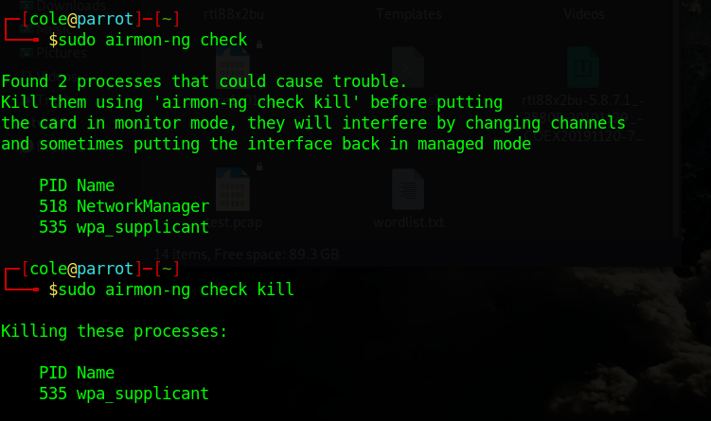

So I ended up doing this at home as I could not complete the lab in class due to the previous error. I confirmed my adapter was in monitor mode.

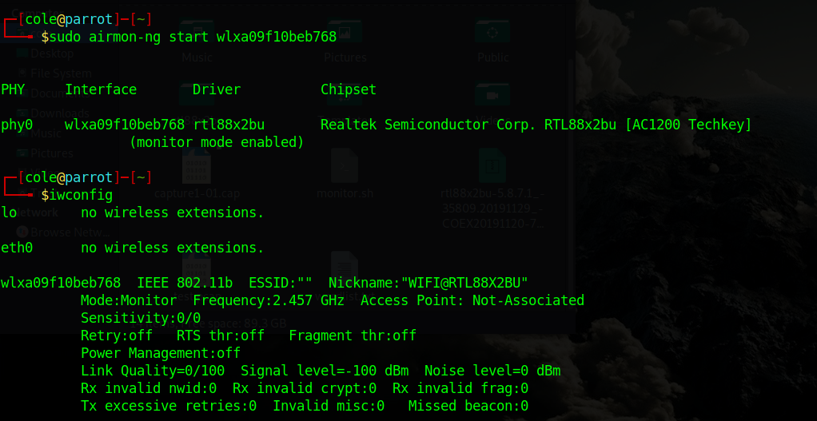

I then check the network to see discoverable devices:

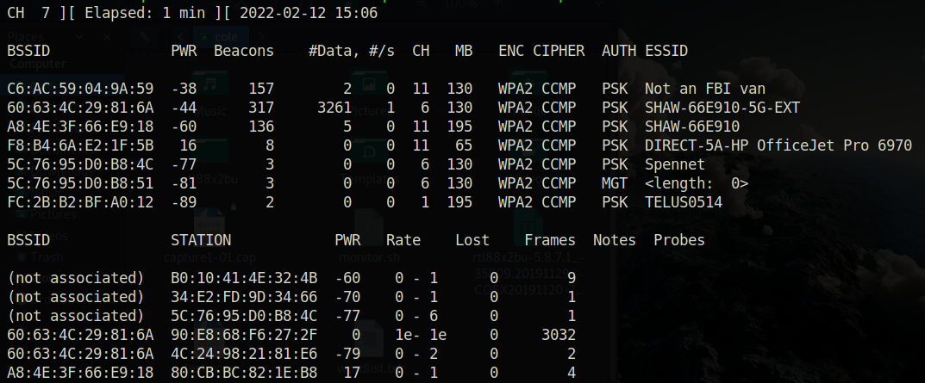

After which I decided to attack my home wifi (SHAW-66E910), I captured packets specifically from that wifi.

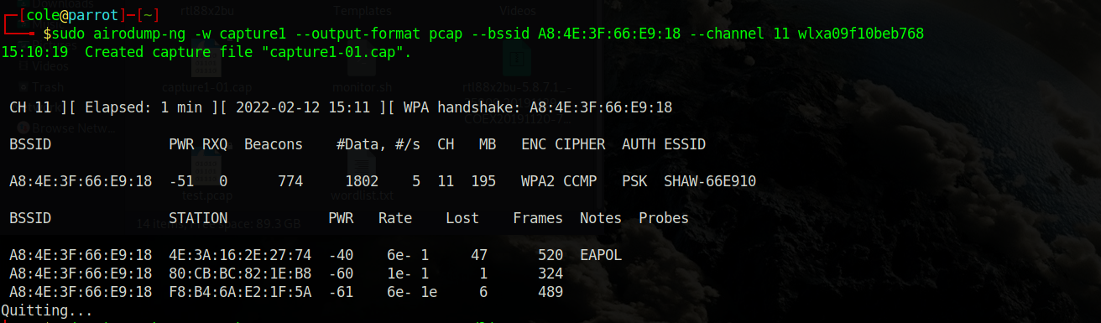

After which I ran aircrack-ng and cracked the wifi!

